Student worksheet

7.4 Electrons are arranged in shells

Pages 140–141 and 219

Arranging electrons

1 How are the electrons of atoms arranged?

2 How many electrons can fill the following shells?

a first \_\_\_\_\_\_\_\_\_\_\_\_\_\_\_\_\_\_\_\_\_\_\_\_\_\_\_\_\_\_\_\_\_\_\_\_\_\_\_\_\_\_\_\_\_\_\_\_\_\_\_\_\_\_\_\_\_\_\_\_\_\_\_\_\_\_\_

b second \_\_\_\_\_\_\_\_\_\_\_\_\_\_\_\_\_\_\_\_\_\_\_\_\_\_\_\_\_\_\_\_\_\_\_\_\_\_\_\_\_\_\_\_\_\_\_\_\_\_\_\_\_\_\_\_\_\_\_\_\_\_\_\_\_\_\_

c third \_\_\_\_\_\_\_\_\_\_\_\_\_\_\_\_\_\_\_\_\_\_\_\_\_\_\_\_\_\_\_\_\_\_\_\_\_\_\_\_\_\_\_\_\_\_\_\_\_\_\_\_\_\_\_\_\_\_\_\_\_\_\_\_\_\_\_

d fourth \_\_\_\_\_\_\_\_\_\_\_\_\_\_\_\_\_\_\_\_\_\_\_\_\_\_\_\_\_\_\_\_\_\_\_\_\_\_\_\_\_\_\_\_\_\_\_\_\_\_\_\_\_\_\_\_\_\_\_\_\_\_\_\_\_\_\_

3 How should electrons be arranged in electron shell diagrams?

4 What is the valence shell of an atom?

5 Why is the valence shell so important?

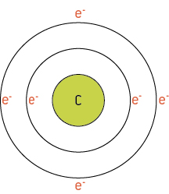6 Draw electron shell diagrams for the following atoms and write the electron configuration next to each diagram. Carbon has been done for you.

*Electron Configuration: 2, 4*

a Draw the electron configuration of nitrogen and state what its electron configuration is.

*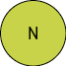 Electron Configuration:*

b Draw the electron configuration of lithium and state what its electron configuration is.

***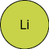*** *Electron Configuration:*

c Draw the electron configuration of beryllium and state what its electron configuration is.

***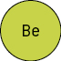*** *Electron Configuration:*

d Draw the electron configuration of boron and state what its electron configuration is.

*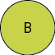 Electron Configuration:*

e Draw the electron configuration of oxygen and state what its electron configuration is.

* Electron Configuration:*

f Draw the electron configuration of fluorine and state what its electron configuration is.

* Electron Configuration:*

Extend your understanding

The periodic table contains groups and periods. Groups are the columns of the periodic table and periods are the rows. The following snapshots have been taken of groups and periods in the periodic table.

7 Draw the electron configuration and determine what pattern is produced by elements in the same group of the periodic table.

|  |  |  |
| --- | --- | --- |
| Group 8 elements | Period Number | Electron Shell Diagram and Electron Configuration: |
| SW0725_01026 |  | Electron Configuration: |
| SW0726_01026 |  | Electron Configuration: |
| SW0727_01026 |  | Electron Configuration: |

8 What happens to the electron shell diagram and electron configuration as you move down groups in the periodic table?

9 Draw the electron configuration and determine what pattern is produced by elements in the same group of the periodic table.

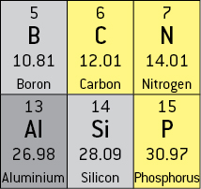

|  |  |  |
| --- | --- | --- |
| a Boron electron shell diagram:  Electron configuration: | b Carbon electron shell diagram:  Electron configuration: | c Nitrogen electron shell diagram:  Electron configuration: |
| d Aluminium electron shell diagram:  Electron configuration: | e Silicon electron shell diagram:  Electron configuration: | f Phosphorous electron shell diagram:  Electron configuration: |

10 What happens to the electron shell diagram and electron configuration as you move across periods in the periodic table?

11 How could you use the periodic table as a cheat sheet for determining electron configuration?